**OBJECTIVE**

Breast cancer is one of the most common cancers worldwide, therefore, it is imperative to raise awareness about it. There are various diagnostic methods to detect breast cancer at an early stage such as breast self-examination, ultrasound, mammography, and biopsy.

As per the data provided by the American Cancer Society, if breast cancer is detected early and is in the localized stage, then the 5-year relative survival rate is 99%.

Keeping this in mind, developing a comprehensive app would prove to be an effective way of creating awareness. Our technological solution- **Pink+**renders a platform that is dedicated to four types of users –

1. **Breast cancer survivors**

Survivors will be able to voice their stories wherein they’ll share personal experiences and guide patients in support groups that, in turn, will help others on a similar journey. Individuals who are facing a cancer diagnosis, or any other illness or hardship, hearing stories of those who've experienced one already can be an incredible wellspring of solace and strength.

1. **Breast cancer patients**

There are several ways to support a Breast cancer patient and we are doing our bit by providing them with a platform where they can get expert advice by uploading their cytology reports.

We’ll also try to get patients in support groups with those who’ve recovered and were in a similar situation that they’re currently in, using Machine Learning algorithms.

**What sets us apart?**

To respect the privacy of users, all reports shared with medical professionals will be anonymous and these professionals will act as an additional human layer between the Machine Learning models and the patient. Right to privacy is an integral part of our technological development, hence, we have incorporated a custom Blockchain for symptom logging which further strengthens data security.

1. **Medical experts/ Professionals**

Collaborate is a forum for researchers, scientists and people alike to discuss and collaborate. Experts have an option to create a new post to share their recent findings, look for research partners or just to share their opinions. All posts will have a ‘tag’ associated with them that makes it easy for other experts to filter posts of their liking.

**Standout feature:** The functionality of collaboration is that it serves a dedicated chat and discussion panel for each post in the section. We believe this will be the host of brilliant ideas, possibly moving us one step closer to an eventual cure.

1. **General public**

They will be able to view survivor stories and content uploaded by medical experts. Individuals can use Symptom Logging to log their day-to-day health and share it with anyone, using any application of their choice, be it Mail or Instant Messaging. To bring in diverse groups of people to interact, individuals from the general public can take part in our campaigns.

**TECH IMPLEMENTATION**

The front-runner of the platform is the mobile application. Built natively using *Swift*, the application runs on both iOS and iPadOS. Our AppleWatch tracker, also built using *Swift* is a separate application that communicates with the main app.

For data storage, a strategic decision had to be made keeping in mind the future goals we have for *Pink+*. With this in mind, we decided to use Google’s *Firebase* because of its ease-of-use, rapid integration and most importantly, scalability and cross-platform support. Firebase's Realtime Database is used for all data storage and Firestore is used for chat in support groups. Other possibilities that were considered were *Core Data* and *Strapi* with *MongoDB Atlas*. The former was not used due to its platform dependence and the headless CMS wasn’t used because of time constraints. The UI elements are built mostly in Sketch and AdobeXD.

For most part, the application is a collection of reading and writing requests from Firebase. Some distinct parts are; News, Risk Evaluation and ML-based diagnosis of lab reports. To solve our issue with collecting latest news articles related to the topic, we used *newsapi.org*’s NewsAPI, which allowed us to filter articles based on the keyword of our choice, i.e, ‘Breast Cancer’.

A custom blockchain is implemented in Swift to further strengthen data security. All health data of the users are stored on this blockchain for enhancing privacy. Instead of using our app as a Geth node for Ethereum, we implemented an in-house Blockchain to avoid calling external methods and to increasing the performance speed of the application. This also allows us to enable cashless accumulations to the blockchain.

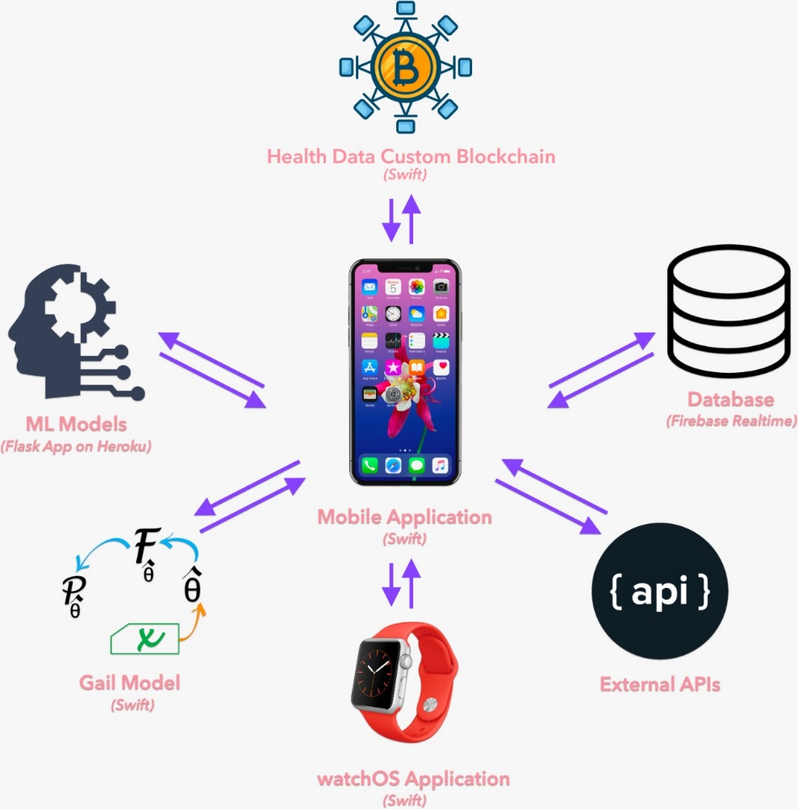

Fig 1: Technical Framework

The distinctive risk evaluation in *Pink+* uses basic demographic information of an individual to assess their risk of getting Breast Cancer in the next five years compared to an individual of the same age with no risk factors in a minified version of the famed Gail model, originally developed by Dr. Mitchell Gail and his team, it is generally regarded as the industry standard of Statistical Breast Cancer risk assessment. Unfortunately, the model only has web-based calculators on websites like cancer.gov and doesn’t have a simple API which developers can call to give evaluation interpretations to their users. Instead of externally integrating a third-party implementation of the model in our app, we’ve reverse-engineered the model using the source and public code snippets in Python and JavaScript.

Several tests were conducted using the same values on our model and the one available publicly to check the accuracy of our implementation, which was reported to be within 1%. To the best of our knowledge, our realization is the only one currently available that’s written natively in Swift or deployed internally on a mobile application. This gives our user total control over their privacy. Instead of sending their data off to an external API, we process it internally without warehousing any sensitive information.

The three ML models which we use (Blood Test evaluation, Recurring Tumor detection and Cytology evaluation) were all developed in Python. We exported the final models to Pickle files, which were used to physique three distinct APIs using Flask, all deployed on Heroku.

The app communicates with this Flask Application to get the analysis done. Public data sets from Kaggle and UCI were expended for training the models.

|  |  |
| --- | --- |
| **Blood Test Analysis to detect Breast Cancer** | |
| Dataset | [data.world/marshalldatasolution/breast-cancer](https://data.world/marshalldatasolution/breast-cancer) |
| Testing Accuracy *(%)* | 75% |
| F1 Score *(1 is best)* | 0.62 (Healthy) and 0.81 (Patients) |

|  |  |
| --- | --- |
| **Cytology Report Analysis to detect Breast Cancer** | |
| Dataset | [kaggle.com/merishnasuwal/breast-cancer-prediction-dataset](https://www.kaggle.com/merishnasuwal/breast-cancer-prediction-dataset) |
| Testing Accuracy *(%)* | 93% |
| F1 Score *(1 is best)* | 0.90 (Benign) and 0.95 (Malignant) |

|  |  |
| --- | --- |
| **Tumor Analysis to predict recurring events of Breast Cancer in the patient** | |
| Dataset | [github.com/datasets/breast-cancer](https://github.com/datasets/breast-cancer) |
| Testing Accuracy *(%)* | 85% |
| F1 Score *(1 is best)* | 0.86 (False Recurrence Events) and 0.83 (Recurrence Events) |

**APP STRUCTURE**

1. **Wellness**   
   In addition to imparting symptom logging and risk assessment services, Pink+ also provides Machine Learning-based diagnosis using Cytology Reports and screening examinations using Blood Test Reports. We believe these diagnostic tools, combined with our risk evaluator will help in the early detection of Breast Cancer.
2. **Support groups**

Pink+ users can make use of a diverse array of support groups available to them. Each support group has a dedicated chat linked to that which is distinct from the others. Acting like de-facto Slack channels of their own, we have Support groups divided into regional communities and the categories of users, so that those battling Breast Cancer can directly talk to Survivors and Expert, and vice-versa.

We believe this can help link together people of same interests together, and also help bring people who can help each other under a common umbrella.

To ensure we still achieve our wider goal of catering to a global population, both kinds of divisions have a global room, accessible to all.

1. **Survivor stories**

Survivor stories can play a vital role in creating a sense of positivity and helping those in the woods. Sometimes they can work as inspirations and at times even replicate the solutions. Therefore, this section will act as a mirror that reflects sunshine.

1. **Breast cancer education**

We can reduce the stigma of Breast cancer through enhanced cancer education. The intended purpose of this section is for professionals to upload educational content about Breast Cancer. A salient feature available to the uploaders is to plug in photos and videos to make it more appealing and to convey their knowledge visually. This is categorized into 5 sections-

1. Brief insights about Breast cancer
2. Early detection methods
3. Diagnosis
4. Prognosis
5. Myths and facts
6. **Campaigns**

To have comprehensive global coverage, we have chosen four ways to promote social awareness on the issue of Breast cancer prevention, precaution and remedies. Taking into account the current scenario, all four of them will have an effective media outreach and will raise awareness about detection, treatment, and the need for a reliable, permanent cure-

1. **Online streaming**

For content creators on YouTube, **Pink+** provides a template for channel arts which the creators can use to proudly mirror their association with the Awareness campaign. The template is designed in accordance to YouTube’s community guidelines and in-line with the specifications for channel arts. We intend to offer an extensive assortment of channel arts soon.

1. **Social media**

Users of Social Media platforms like Instagram can make use of our story templates, reflecting several taglines resonating with the campaign. Pink+will provide its users to download one of several templates, available in different dimensions corresponding to phone resolutions. These story templates can also be used on Instant Messaging platforms like WhatsApp and Telegram. Lastly, we’re proud to state that our in-house filter has been approved by Instagram and is now a part of the public gallery of filters on the app. All Instagram users can use the filter and swank their involvement with the movement.

1. **Print media**

Print media remains one of the most conventional forms of creating awareness amongst the masses. With India at the cusp of the digital revolution, print media still holds an edge over electronic media and can play a praiseworthy role in disseminating information to every nook and cranny of the country. Therefore, dedicating a pink page to Breast cancer education would do the needful.

1. **Online classes**

Educational institutions can introduce a new non-evaluative subject to imbibe basic knowledge about Breast cancer or they can invite specialized doctors to their classes to discuss the issue with students to answer their queries.

**FUTURE ROADMAP**

**Fundraising:** Collaborative scheme is one of the ways we shall raise funds, a boon to companies/organisations that want to maximize their resources to expand their reach and impact.

Following 3C Model (Cooperation, Coordination, Collaboration) we shall create a global crowdfunding community for non-profitable organisations, donors, and companies. Moving the needle requires identification of a potential collaborative partner, in our case, the following could be our channel partners:

* Pharmaceutical companies
* Med apps
* Surgical instrument manufacturer
* Diagnostic companies (including online)
* National & International NGO’s

**Mammography:** Users can self-diagnose medical imaging of their mammography tests using our Deep Learning models. According to articles published in reputed journals like Nature, Deep Learning based analysis have already beaten Doctors and Lab Technicians in detecting the presence of cancerous tissues, all in a fraction of time compared to what humans take.

**Multi-platform extension:**

* Android app development
* Website
* Multi-lingual support

**Additional Campaigns:** One of the biggest industries in the world is the sports and gaming industry. Around 80% of the world’s population irrespective of age is involved in this industry in one way or the other. This form of media can be a bewildering platform for spreading awareness to a large audience. Cricketers can use a sticker on their bats or design their uniform in a manner that helps in spreading the message just like South Africa’s National Team uses their pink uniform to spread awareness amongst the public. Online games can also display a message and use these color-coded items in their games to spread the message.